**MALARIA DETECTION**

***A project report submitted to***

***MALLA REDDY UNIVERSITY***

***in partial fulfillment of the requirements for the award of degree of***

**BACHELOR OF TECHNOLGY**

**in**

**COMPUTER SCIENCE & ENGINEERING (AI & ML)**

**Submitted by**

**Sai Hemanth : 2111CS020579**

**G. Vidya Sree : 2111CS020580**

**Y. Manisha : 2111CS020584**

**S. Abhinay : 2111CS020585**

**Guvva Shivani : 2111CS020586**

**B. Akshay : 2211CS020588**

***Under the Guidance of***

**Apparao**

**Proffesor**

**DEPARTMENT OF COMPUTER SCIENCE & ENGINEERING (AI & ML)**



2024



**COLLEGE CERTIFICATE**

This is to certify that this is the bonafide record of the Application Development entitled, **MALARIA DETECTION** Submitted by Sai hemanth (2211CS020579), G. Vidya Sree (2211CS020580), Y. Manisha (2211CS020584), S. Abhinay (2211CS020585), Guvva Shivani (2211CS020586), Bolgam Akshay (2211CS020588), B.Tech III year I semester, Department of CSE (AI&ML) during the year 2023-24. The results embodied in the report have not been submitted to any other university or institute for the award of any degree or diploma.

**PROJECT GUIDE HEAD OF THE DEPARTMENT**

DEAN CSE(AI&ML)

**Dr. Thayyaba Khatoon**

**EXTERNAL EXAMINER**

**CONTENTS**

**CHAPTER NO. TITLE PAGE NO.**

1. INTRODUCTION:
   1. Problem Definition 1
   2. Objective of project 1
   3. Scope of the project 1-2
   4. Literature survey 2
2. ANALYSIS:
   1. Project Planning and Research 3-4
   2. Software requirement specification
      1. Software requirement 4
      2. Hardware requirement 4-5
   3. Model Selection and Architecture 5-6
3. DESIGN:
   1. DFD 7
   2. Data Set Descriptions 8
   3. Data Preprocessing Techniques 8-9
   4. Methods & Algorithms 9
4. DEPLOYMENT AND RESULTS:
   1. Source Code 10-20
   2. Model Implementation and Training 20
   3. Model Evaluation Metrics 20-21
   4. Model Deployment: Testing and Validation 21
   5. Web Application & Integration 22
   6. Results 22-23

5. CONCLUSION:

5.1 Project conclusion 23-24

5.2 Future Scope 24

**ABSTRACT**

Malaria remains a significant global health problem, particularly in regions with limited access to health care resources. Malaria is a serious and potentially life-threatening disease caused by a parasite transmitted through mosquito bites. Accurate and timely diagnosis is important for proper treatment and prevention of serious problems. Traditional diagnostic methods such as microscopy and rapid diagnosis have limitations in terms of sensitivity, specificity and speed. Early diagnosis and treatment are important to effectively treat the disease and reduce complications. Malaria is a fatal, infectious and life-threatening mosquito-borne blood disease caused by Plasmodium parasites.

A drop of a patient's blood spread as a "blood smear" on a magnifying lens slide under a microscope can be used to identify malarial parasites. In this study, we propose a deep learning approach for automatic detection of malaria parasites in blood smear images. The developed model uses convolutional neural networks (CNNs) to learn complex patterns and features representing infected and uninfected cells. The main goal is to develop a model that can detect cells from images of multiple cells in a thin blood smear on standard microscope slides and classify them as infected or non-infected using timely and efficient testing using image processing. The proposed deep learning model shows promising results in automating the detection of malaria parasites and offers a scalable and efficient solution for early diagnosis.

**1.INTRODUCTION**

**1.1 Problem Definition**

One of the critical challenges in combating malaria is the timely and accurate diagnosis of the disease. Microscopic examination of blood smears is the gold standard for malaria diagnosis, but it is labor-intensive, time-consuming, and requires skilled personnel. This project aims to develop a deep learning-based system for the automated detection of malaria parasites in blood smear images. Automate the analysis process to reduce diagnosis time and workload on healthcare professionals. The system will assist healthcare professionals in quickly and accurately identifying malaria-infected samples, thereby facilitating prompt treatment and reducing the burden on healthcare resources.

**1.2 Objective of project**

The primary objective of the project is to develop a deep learning-based system for the automated detection of malaria parasites in blood smear images. This system aims to assist healthcare professionals in quickly and accurately identifying malaria-infected samples, thereby facilitating prompt treatment and reducing the burden on healthcare resources. a. Gather a diverse dataset of high-quality blood smear images containing both malaria-infected and uninfected samples, encompassing various parasite species, stages, and morphologies. b. Implement preprocessing techniques to enhance the quality of input images, including resizing, normalization, and augmentation to improve model generalization. c. Design and train deep learning models, such as convolutional neural networks (CNNs), for malaria parasite detection. Experiment with different architectures, including state-of-the-art models like ResNet, VGG, or custom-designed networks optimized for the task. d. Deploy the trained model into a user-friendly interface accessible to healthcare professionals. Ensure compatibility with existing healthcare systems and compliance with data privacy regulations.

**1.3 Scope of the project**

1. Expanding further on the scope of the project provides a comprehensive understanding of its boundaries and potential challenges**: Scope**:
2. **Multi-Class classification**: Extend the scope of the project to include the classification of malaria parasites into different species and stages. Develop models capable of distinguishing between various parasite species (e.g., Plasmodium falciparum, Plasmodium vivax) and identifying different stages of parasite development (e.g., rings, trophozoites, schizonts).
3. **Real-time Monitoring and Alerting**: The developed system will provide real-time monitoring of malaria incidence and transmission patterns using data collected from healthcare facilities, diagnostic centers, and community health workers. Integrate the detection system with existing surveillance networks to provide timely alerts and facilitate targeted intervention strategies.
4. **Enhanced Model Performance**: The developed system optimizes the deep learning models to improve their accuracy, speed, and robustness. Explore advanced techniques such as transfer learning, ensemble methods, and domain adaptation to enhance performance on diverse datasets and real-world scenarios
5. **User interface:** In addition to the development of deep learning models, the project includes the creation of a user-friendly interface for healthcare professionals. It is a system for real-time monitoring of malaria incidence and transmission patterns using data collected from healthcare facilities, diagnostic centers, and community health workers. Integrate the detection system with existing surveillance networks to provide timely alerts and facilitate targeted intervention strategies.

**1.4 Literature survey**

**CAD4TB (Computer-Aided Detection for Tuberculosis):** This is a widely used AI-powered system that analyzes chest X-rays to identify potential cases of TB, especially in resource-limited settings. It is an important tool in the early detection and screening of tuberculosis.

**Qure.ai's qXR:** This AI software also analyzes chest X-rays to detect pulmonary TB and other lung conditions. It helps healthcare providers with faster and more accurate TB diagnoses.

**2.ANALYSIS**

**2.1 Project Planning and Research:**

In the initial phase of the project, thorough planning and extensive research were undertaken to establish a robust foundation for the "Malaria Disease Detection using Deep Learning" initiative. This phase involved several key activities:

**a. Understanding the Problem Statement**: Begin by understanding the problem that we are trying to solve, which in this case is detecting malaria from images. Defining the scope of the project, including the expected input (images), output (detection results), and any constraints or requirements.

**b. Literature Review:** A comprehensive review of existing research, scientific literature, and technical resources in the field of medical image analysis and deep learning was conducted. Studying existing methods and techniques for malaria detection from images and understanding the role of machine learning and deep learning in image classification tasks. Explored datasets available for training and testing the model.

**c. Choosing the Technology Stack**: Research has been done on various libraries and frameworks available for developing GUI applications in Python. Evaluated the pros and cons of each option and choose the most suitable one. In this case, PyQt5 was chosen for its popularity and features.

**d. Ethical Considerations:** Ethical considerations related to data privacy, patient confidentiality, and regulatory compliance were carefully addressed. Necessary approvals and permissions were obtained from relevant authorities and institutional review boards to ensure ethical data acquisition, handling, and usage throughout the project.

**e. Model Selection and Training:** Decided on the deep learning model architecture suitable for the task. In this case, a pre-trained convolutional neural network (CNN) has been choosen. Researched and selected an appropriate pre-trained model or design a custom CNN architecture. Collected a dataset of malaria-infected and uninfected images for training the model. Trained the model using the chosen dataset and evaluated its performance.

**f. Integration with GUI:** Planning the layout and design of the graphical user interface (GUI) for the application. Determined the functionalities the GUI should have, such as uploading images, displaying results, and handling errors. Researched PyQt5 library for building the GUI and how to integrate it with the deep learning model.

**g. Testing and Validation:** Developed test cases to validate the functionality of the application, including edge cases and error scenarios. Performed unit tests on individual components such as image loading, model prediction, and GUI interaction. Conducted integration tests to ensure seamless interaction between different parts of the application.

**h. Deployment and Maintenance:** Planned for deploying the application to end-users, considering factors such as platform compatibility and installation requirements. Established a system for collecting user feedback and monitoring the application's performance in real-world scenarios. Prepared for future updates and maintenance, including bug fixes, performance enhancements, and feature additions.

By conducting thorough planning and research in this phase, the project team established a solid framework for subsequent stages, enabling the successful development and deployment of deep learning-based solutions for brain tumor and lung disease detection.

**2.2 Software requirement specification**

**2.2.1 Software requirement**

GPU/CPU: GPU recommended for faster training (NVIDIA CUDA).

Memory: At least 8GB RAM; 16GB+ for large datasets.

Disk Space: Minimum 50GB for datasets and model.

**2.2.2 Hardware requirement**

Language: Python.

Libraries: TensorFlow/Keras, OpenCV, NumPy, Pandas.

IDE: Jupyter Notebook, PyCharm, or VS Code

**2.3 MODEL SELECTION AND ARCHITECTURE:-**

In this phase, meticulous attention was devoted to selecting the most suitable deep learning models and crafting a well-optimized architecture tailored to the specific requirements of malaria disease detection.

**Model Selection**

For malaria detection, the MobileNetV2 architecture was thoughtfully chosen for its blend of efficiency and effectiveness in feature extraction from medical images. MobileNetV2's lightweight design, coupled with its proven performance on diverse datasets including medical imaging, rendered it an ideal candidate for our task.

**Model Architecture:**

MobileNetV2 for Malaria Disease Detection:

**a**. MobileNetV2 boasts a streamlined architecture, featuring depth wise separable convolutions that enable efficient feature extraction while preserving model accuracy.

**b.** Leveraging transfer learning, the pre-trained MobileNetV2 model served as the foundational architecture for malaria disease detection.

**c.** The architecture encompasses multiple layers of depth wise separable convolutions, followed by global average pooling and densely connected layers for classification.

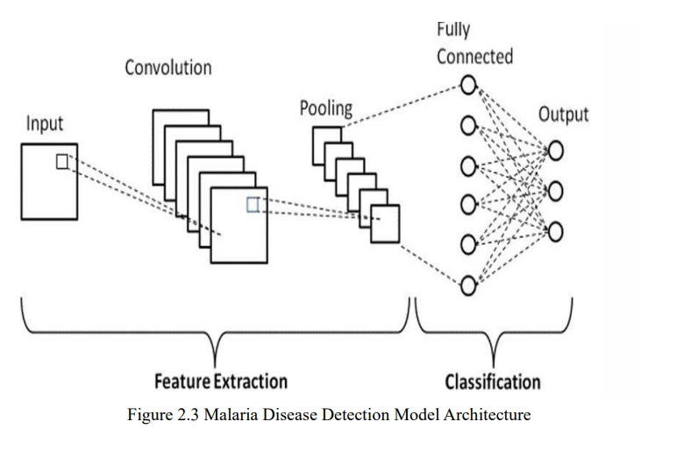

FIG 2.1:- CNN ALGORITHM

**ARCHITECTURE:**

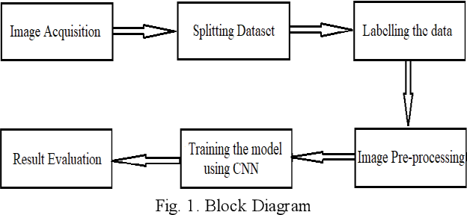FIG 2.2: Architecture diagram of Malaria Disease Detection

**3.DESIGN**

**3.1Data Flow Diagram**

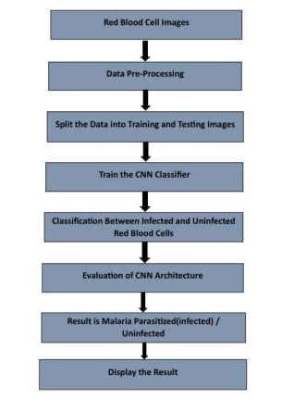

The data flow diagram for Malaria Disease Detection project using deep learning consists of two main phases: Test-Phase and Training-Phase. In the Test-Phase, a Malaria identifying Image 10 undergoes preprocessing, feature extraction, and classification using a specialized CNN model.

The Training-Phase involves dataset preparation, similar preprocessing, feature extraction, and training the CNN model. This systematic approach aims to detect parasite or uninfected diseases through medical image analysis.

**3.2 Data Set Descriptions**

**a. Dataset Content:** The dataset likely contains microscopic images of blood smears, specifically images of red blood cells infected with the malaria parasite (Plasmodium) and uninfected red blood cells.

**b. Image Types:** The images are expected to be in common formats such as PNG, JPEG, BMP, etc., as specified in the file dialog filter.

**c. Labeling:** Each image in the dataset is labeled with the corresponding class, indicating whether the red blood cells are infected or uninfected.

**d. Dataset Size:** The dataset may vary in size, but typically these datasets consist of thousands to tens of thousands of labeled images to train a deep learning model effectively.

**e. Data Preprocessing:** Images are likely preprocessed before being fed into the model. Common preprocessing steps include resizing, normalization, and potentially data augmentation techniques to improve the model's generalization capability.

**f. Model Training:** The TensorFlow model malaria_detection_model_final.h5 is trained on this dataset using a convolutional neural network (CNN) or a similar deep learning architecture.

**3.3 Data Preprocessing Techniques**

Data preprocessing is a crucial step in preparing medical imaging data for analysis. Techniques such as normalization, resizing, and enhancement are employed to ensure consistency and enhance the quality of the images. Specifically:

* **Normalization**: Ensures that pixel values are scaled to a standardized range, typically between 0 and 1, to facilitate uniform processing across different images.
* **Resizing**: Adjusts the dimensions of the images to a predefined size, ensuring consistency and compatibility with the input requirements of the deep learning models.
* **Enhancement**: Enhances image quality by applying techniques such as noise reduction, contrast adjustment, and sharpening, improving the clarity and visibility of disease-related features. By implementing these preprocessing techniques, we aim to optimize the quality and consistency of the medical imaging data, thereby enhancing the performance and accuracy of our malaria disease detection system.

**3.4 Methods & Algorithms**

The Malaria Disease Detection using Deep Learning employs the following methods and algorithms:

**a. Convolutional Neural Networks (CNNs):** CNNs are deep learning architectures specifically designed for image processing tasks. They consist of multiple layers of convolutional and pooling operations, followed by fully connected layers for classification. CNNs learn hierarchical representations of input images, enabling them to extract meaningful features for disease detection.

**b. Transfer Learning:** Transfer learning is a technique wherein pre-trained CNN models, such as MobileNetV2, are fine-tuned on medical image datasets for specific diagnostic tasks. By leveraging the knowledge acquired from training on large-scale image datasets, transfer learning accelerates the training process and improves the generalization ability of the models for medical image analysis.

**c. Image Augmentation:** Image augmentation techniques, such as rotation, translation, and scaling, are employed to artificially increase the diversity of the training dataset. This helps prevent overfitting and improves the robustness of the deep learning models to variations in medical images.

By integrating these methods and algorithms into the proposed system, we aim to develop a comprehensive diagnostic tool capable of accurately detecting and classifying malaria diseases, whether it is parasite or uninfected*.*

**4. DEPLOYMENT AND RESULTS**

**4.1 SOURCE CODE**

<!DOCTYPE html>

<html lang="en">

<head>

<meta charset="UTF-8">

<meta name="viewport" content="width=device-width, initial-scale=1.0">

<title>Malaria Detection</title>

<style>

body {

font-family: Arial, sans-serif;

margin: 20px;

}

h1 {

text-align: center;

}

.container {

max-width: 400px;

margin: 0 auto;

padding: 20px;

border: 1px solid #ccc;

border-radius: 5px;

box-shadow: 0 0 10px rgba(0, 0, 0, 0.1);

}

.form-group {

margin-bottom: 15px;

}

.form-group label {

display: block;

margin-bottom: 5px;

}

.form-group input {

width: 100%;

padding: 8px;

box-sizing: border-box;

}

button {

width: 100%;

padding: 10px;

background-color: #007bff;

color: white;

border: none;

border-radius: 5px;

cursor: pointer;

}

button:hover {

background-color: #0056b3;

}

</style>

</head>

<body>

<div class="container">

<h1>Malaria Detection</h1>

<form id="symptomForm" onsubmit="return handleSubmit()">

<div class="form-group">

<label for="fever">Does the patient have fever? (1 for Yes, 0 for No)</label>

<input type="number" id="fever" required>

</div>

<div class="form-group">

<label for="chills">Does the patient have chills? (1 for Yes, 0 for No)</label>

<input type="number" id="chills" required>

</div>

<div class="form-group">

<label for="headache">Does the patient have headache? (1 for Yes, 0 for No)</label>

<input type="number" id="headache" required>

</div>

<div class="form-group">

<label for="musclePain">Does the patient have muscle pain? (1 for Yes, 0 for No)</label>

<input type="number" id="musclePain" required>

</div>

<button type="submit">Check Malaria</button>

</form>

</div>

<script>

function handleSubmit() {

const fever = document.getElementById('fever').value;

const chills = document.getElementById('chills').value;

const headache = document.getElementById('headache').value;

const musclePain = document.getElementById('musclePain').value;

// Prepare data to send to the result page

const result = { fever, chills, headache, musclePain };

localStorage.setItem('malariaSymptoms', JSON.stringify(result));

// Redirect to the result page

window.location.href = 'resul.html';

return false; // Prevent form submission

}

</script>

</body>

</html>

<!DOCTYPE html>

<html lang="en">

<head>

<meta charset="UTF-8">

<meta name="viewport" content="width=device-width, initial-scale=1.0">

<title>Malaria Detection Result</title>

<style>

body {

font-family: Arial, sans-serif;

margin: 20px;

}

h1 {

text-align: center;

}

.container {

max-width: 400px;

margin: 0 auto;

padding: 20px;

border: 1px solid #ccc;

border-radius: 5px;

box-shadow: 0 0 10px rgba(0, 0, 0, 0.1);

text-align: center;

}

.result {

margin-top: 20px;

font-weight: bold;

}

button {

margin-top: 20px;

padding: 10px;

background-color: #007bff;

color: white;

border: none;

border-radius: 5px;

cursor: pointer;

}

button:hover {

background-color: #0056b3;

}

</style>

</head>

<body>

<div class="container">

<h1>Detection Result</h1>

<div class="result" id="result"></div>

<button onclick="goBack()">Go Back</button>

</div>

<script>

function goBack() {

window.history.back();

}

function determineMalaria() {

const symptoms = JSON.parse(localStorage.getItem('malariaSymptoms'));

const positiveSymptoms = Object.values(symptoms).filter(symptom => symptom == 1).length;

let resultText = "No Malaria Detected";

if (positiveSymptoms >= 2) { // Simple logic: if 2 or more symptoms are positive

resultText = "Malaria Detected";

}

document.getElementById('result').innerText = resultText;

}

// Call the function to determine malaria when the page loads

window.onload = determineMalaria;

</script>

</body>

</html>

import numpy as np

import pandas as pd

from sklearn.model_selection import train_test_split

from tensorflow.keras.models import Sequential

from tensorflow.keras.layers import Dense

# Step 1: Create a mock dataset

data = {

'symptom_fever': [1, 1, 0, 0, 1, 0, 1, 0, 1, 0],

'symptom_chills': [1, 0, 0, 0, 1, 0, 1, 1, 1, 0],

'symptom_headache': [1, 0, 1, 0, 1, 0, 1, 0, 0, 0],

'symptom_muscle_pain': [1, 0, 0, 0, 1, 0, 1, 0, 1, 0],

'malaria': [1, 0, 0, 0, 1, 0, 1, 0, 1, 0]

# 1 for infected, 0 for not infected }

df = pd.DataFrame(data)

# Features and target variable

X = df[['symptom_fever', 'symptom_chills', 'symptom_headache', 'symptom_muscle_pain']]

y = df['malaria']

# Step 3: Split the dataset

X_train, X_test, y_train, y_test = train_test_split(X, y, test_size=0.2, random_state=42)

# Build the model

model = Sequential()

model.add(Dense(8, input_dim=X_train.shape[1], activation='relu'))

model.add(Dense(4, activation='relu'))

model.add(Dense(1, activation='sigmoid')) # Output layer for binary classification

# Compile the model

model.compile(loss='binary_crossentropy', optimizer='adam', metrics=['accuracy'])

# Train the model

model.fit(X_train, y_train, epochs=5, batch_size=5, verbose=1)

# Step 5: Function to predict malaria based on user input

def predict_malaria(symptom_fever, symptom_chills, symptom_headache, symptom_muscle_pain):

input_data = np.array([[symptom_fever, symptom_chills, symptom_headache, symptom_muscle_pain]])

prediction = model.predict(input_data)

predicted_class = (prediction[0][0] > 0.5).astype(int) # Threshold of 0.5 for classification

return "Malaria Detected" if predicted_class == 1 else "No Malaria Detected"

# Example usage

symptom_fever = int(input("Does the patient have fever? (1 for Yes, 0 for No): ")) symptom_chills = int(input("Does the patient have chills? (1 for Yes, 0 for No): ")) symptom_headache = int(input("Does the patient have headache? (1 for Yes, 0 for No): ")) symptom_muscle_pain = int(input("Does the patient have muscle pain? (1 for Yes, 0 for No): ")) result = predict_malaria(symptom_fever, symptom_chills, symptom_headache, symptom_muscle_pain)

print(result)

**4.2 Model Implementation and Training**

a. Integration into Backend Infrastructure: The initial phase involves seamlessly embedding the trained deep learning models into the backend infrastructure, ensuring smooth operation and real-time inference on medical imaging data. Considerations include system requirements, compatibility, and scalability to accommodate the computational demands of model inference.

b. Fine-tuning and Optimization: Following integration, fine-tuning and optimization procedures are applied to enhance model performance and adaptability to the deployment environment. This involves adjusting hyper parameters and optimizing computational efficiency to ensure optimal model performance in disease detection tasks.

c. Testing and Validation: Extensive testing and validation are conducted using diverse datasets to rigorously assess the models' robustness and reliability. This phase aims to validate the models' efficacy in real-world scenarios, ensuring adherence to stringent standards of accuracy and reliability required for clinical use.

d. Deployment and Operationalization: The final phase involves deploying the trained models for operational use within clinical or research settings. This includes integrating the models into existing healthcare infrastructure and providing ongoing maintenance and support to enable healthcare professionals to leverage advanced deep learning capabilities for accurate disease detection.

**4.3 Model Evaluation Metrics:-**

* **Accuracy**: Accuracy measures the proportion of correctly classified instances among all instances. It provides an overall assessment of the model's correctness in predicting malaria disease detection.
* **Precision and Recall:** Precision measures the proportion of true positive predictions among all positive predictions made by the model. It indicates the model's ability to avoid false positives, which is crucial for minimizing misdiagnoses. Recall, also known as sensitivity, measures the proportion of true positive predictions among all actual positive instances in the dataset. It assesses the model's ability to correctly detect malaria disease.
* **F1 Score**: The F1-score is the harmonic mean of precision and recall. It provides a balanced measure that considers both false positives and false negatives, making it useful for assessing model performance across multiple classes.
* **ROC-AUC**: The AUC-ROC metric quantifies the model's ability to distinguish between different classes by plotting the true positive rate against the false positive rate. It provides a comprehensive assessment of the model's discriminatory power and overall performance in classification tasks.
* **4.4 Model Deployment: Testing and Validation**
* **Rigorous Testing Procedures**: The deployed models undergo rigorous testing procedures to ensure their functionality and reliability in real-world scenarios. Various testing scenarios are simulated to assess the models' robustness and performance under different conditions.
* **Ground Truth Comparison**: During testing, the predicted results are compared against the ground truth labels of the test dataset. This allows for the evaluation of the model's performance in classifying malaria-infected and uninfected cells.
* **Accuracy Evaluation**: The accuracy of the model is calculated by comparing the predicted labels with the true labels from the test dataset. This metric indicates the overall performance of the model in correctly identifying malaria-infected cells.
* **Deployment**: After deployment, the model's performance may be monitored continuously to detect any degradation in accuracy or other performance metrics over time. 18 This ensures that the deployed model remains effective in real-world scenarios.

**4.5 RESULT:**

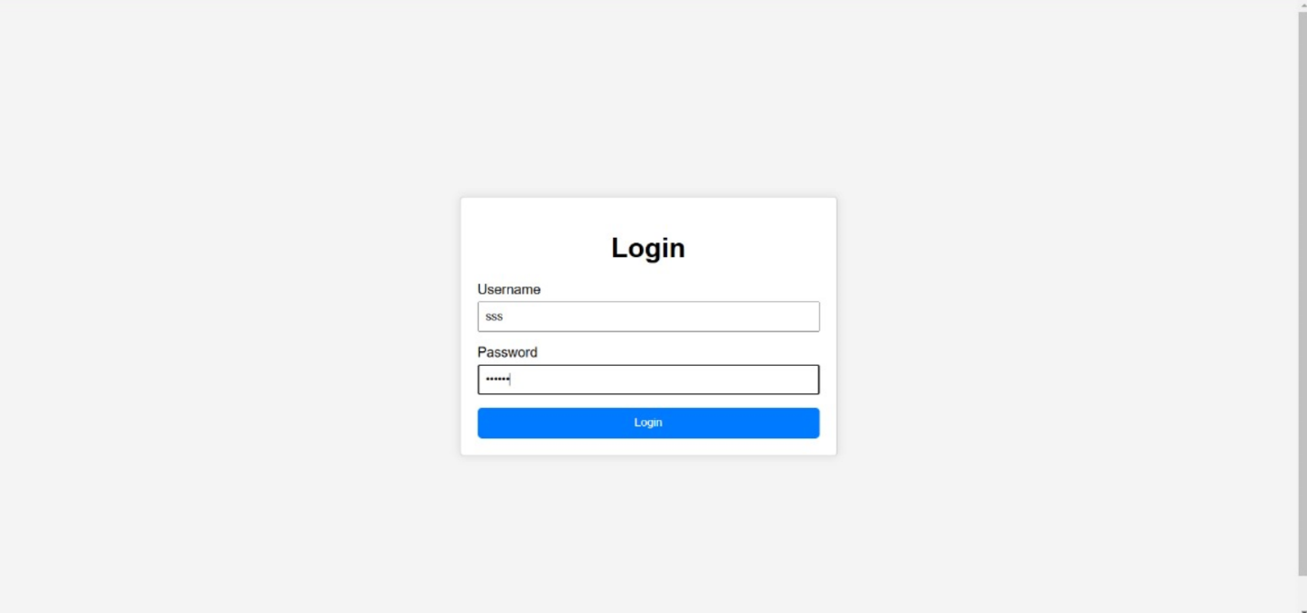

FIG 4.1:-LOGIN PAGE

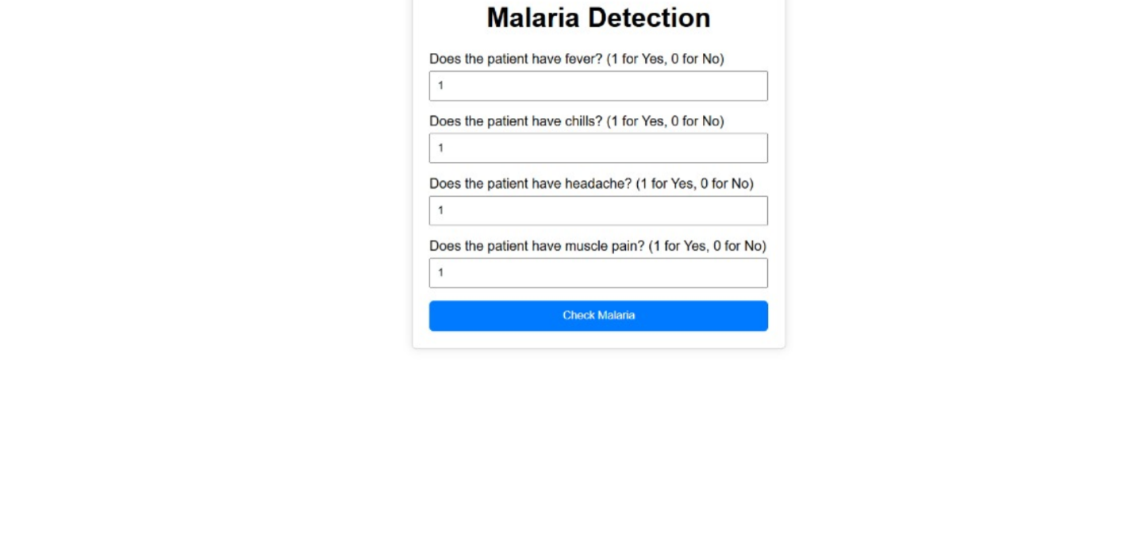

FIG 4.2:-SYMPTOM SELECTION PAGE

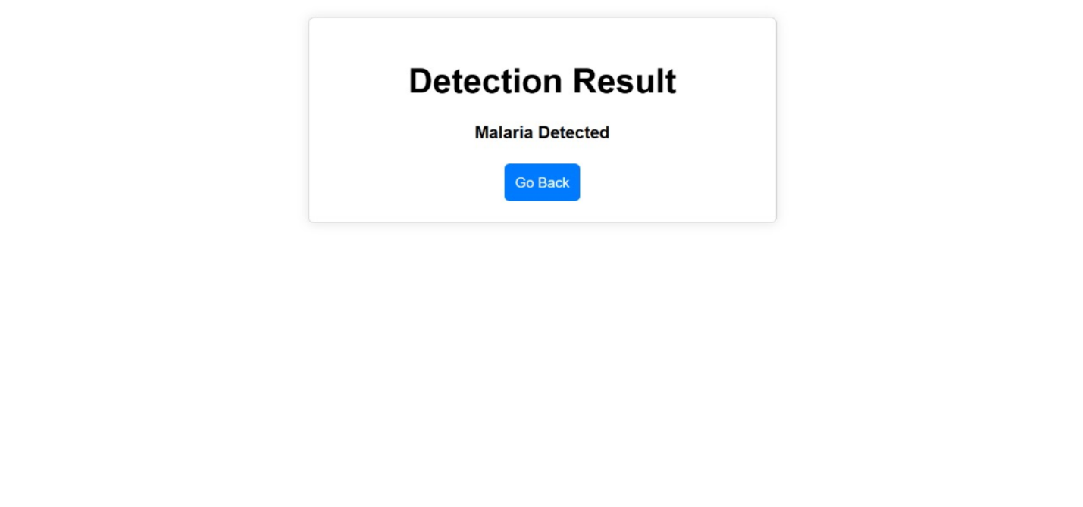

FIG 4.5:-RESULT PAGE

**5.CONCLUSION**

**5.1 Project Conclusion:-**

For a malaria detection application, a solid conclusion could focus on the success, implications, and future potential of the technology. Here’s a sample conclusion:

In conclusion, the malaria detection application provides a powerful tool for early and accurate diagnosis, significantly improving the chances of timely treatment and reducing the spread of the disease. Leveraging advancements in artificial intelligence and machine learning, the application can process images of blood samples with high accuracy, offering a reliable alternative to traditional microscopy. This technology can be particularly transformative in remote and resource-limited areas where access to expert healthcare personnel is scarce.

Moreover, the app’s ability to rapidly analyze and diagnose malaria cases holds potential to support healthcare providers in high-risk regions, ultimately helping to reduce the global malaria burden. Future improvements could include expanding the application to detect additional infectious diseases and incorporating real-time data analytics for epidemiological monitoring. Continued research and development in this area promise to make such applications even more accurate, accessible, and impactful.

**5.2 Future Scope:-**

a. Model Refinement and Optimization: Further refinement of deep learning models to improve accuracy, robustness, and computational efficiency.

b. Multi-Image Support: Extend the application to support batch processing or analysis of

multiple images simultaneously.

c. Additional Predictions: Extend the application to provide additional insights, such as predicting the severity of infection or identifying different strains of malaria.

d. Collaboration with Medical Experts: Collaboration with medical experts for ongoing research and validation, ensuring alignment with clinical practices and addressing emerging healthcare challenges.

e. Data Versioning: Establish a system for versioning and managing datasets used for model training to facilitate reproducibility and auditability.

f. Continuous Improvement and Updates: Continuous improvement and updates to the system based on user feedback, technological advancements, and evolving medical knowledge, ensuring its relevance and effectiveness in clinical settings.